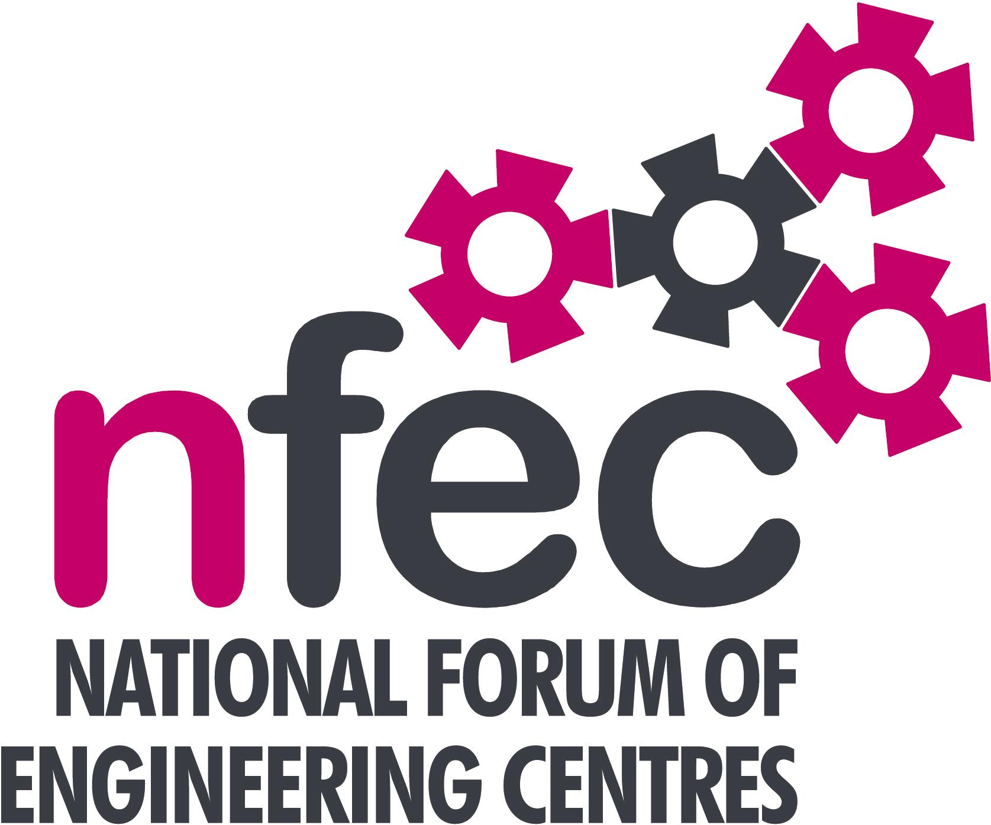
NFEC Spring 2017 North East Regional Seminar

Host: Middlesbrough College

Friday 17th February 2017, 10.15am – 15.00 (Coffee from 10.00am)
Venue: The STEM Centre, Windward Way, Middlesbrough TS2 1QG
Telephone Number: 01642 333999

Programme

- Welcome and Introduction to the Seminar | John Lockey (NFEC Director and North East Regional Coordinator)  Steve Ankers, Middlesbrough College | 10.15
- Current matters of concern relating to quality, content, structure, management and delivery of programmes of training and education in Engineering (not included on Agenda) - an opportunity for open discussion with a focus to distill key issues and plans for addressing them.  Pearson Input and Specific Discussion on HNs  - Qualifications and Awarding Bodies – Current developments and general issues.  - Demonstration by OneFile of software and an app which can be used on and offline to record training as essentially an eportfolio.  - The Composites Technician Trailblazer Apprenticeship  “An opportunity”  Lunch and Demonstrations by Exhibitors  - NEEA Up Date including International Advanced Manufacturing Park (IAMP)  - Trailblazer developments and end point assessment  - Plenary session – Day conference, design competition and issues to note and agreed actions for NFEC  - Date, Place and Topics for next Seminar  Tour of facilities  Close  Entry is free to this seminar for members or non-members present for a first attendance.There will be a charge for non members after this. A light buffet lunch will be provided and you will be able to see/discuss demonstrations of the latest available equipment and facilities for the delivery of learning in Engineering. | All Delegates/John Lockey  Pearson - Simon Bowker  C&G – Simon Yorke  AQA - Dean O’Donoghue  OCR - Martin Webber  EAL – Mark Jones  Johnny Mathieson, One File  Brian Thornton, National Composites Centre  Eddie Leng, Project Manager, The North East Automotive Alliance  Bob Millington, NFEC National Liaison  All Delegates/John Lockey  To book your place: Email: admin@nfec.org.uk  Phone: 07759 901229 | 10.20  11.00  11.30  12.00  12.30  13.15  14.00  14.30  14.45

